TEAM VLISSIDES

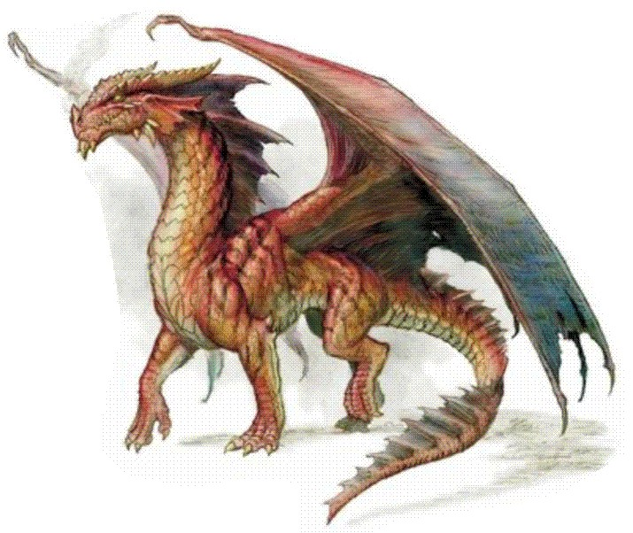

**Regan Fencl, Robert Holliday, Justin Stevenson**

**Project Name:**

**Dragon Cave**

**3/12/2014**